**Practical No. 03**

**Create Conditional Statement using Pl/SQL**

## **If Statement :**

**2)IF ELSE :**

**3)Using elseif Statement :**

**4)Case Statement :**

**Name : Kedar Dere**

**Class :FY.BSc.IT(A)**

**Roll No:11**

**Subject :PL/SQL**

**Sign:**

**Practical No. 03**

**Create Conditional Statement using Pl/SQL**

## **If Statement**

set serveroutput on;

DECLARE

x int:=10;

y int:=80;

BEGIN

if(y>x) then

dbms_output.put_line('Result: ' ||y|| ' is greater than ' ||x);

end if;

END;

/

**Output :**

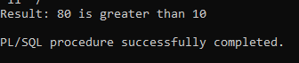

1. **IF ELSE :**

set serveroutput on;

DECLARE

x int;

BEGIN

x := &x;

if mod(x,2) = 0 then

dbms_output.put_line('Even Number');

else

dbms_output.put_line('Odd Number');

end if;

END;

/

**Output :**

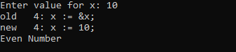

1. **Using elseif Statement**

set serveroutput on;

DECLARE

a int;

b int;

BEGIN

a := 20;

b := 10;

if(a>b) then

dbms_output.put_line(‘a is greater than b’);

elsif(b>a) then

dbms_output.put_line(‘b is greater than a’);

else

dbms_output.put_line(‘Both a and b are equal’);

end if;

END;

/

**Output :**

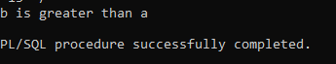

1. **Case Statement :**

DECLARE

grade char(1) := 'A';

BEGIN

CASE grade

when 'A' then dbms_output.put_line('Excellent');

when 'B' then dbms_output.put_line('Very good');

when 'C' then dbms_output.put_line('Good');

when 'D' then dbms_output.put_line('Average');

when 'F' then dbms_output.put_line('Passed with Grace');

else dbms_output.put_line('Failed');

END CASE;

END;

/

**Output :**

